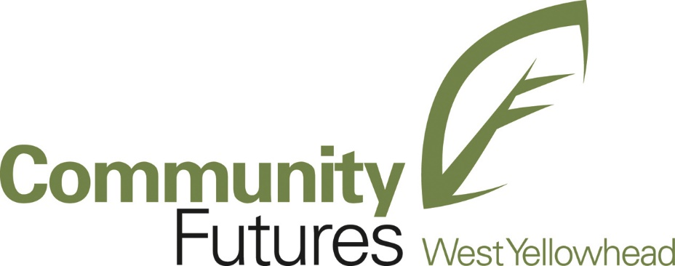

2024 Application Form
Community Futures West Yellowhead offers the Leadership West Yellowhead program - a community leadership program designed to develop the leadership skills and community awareness of the West Yellowhead region’s next generation of leaders. The ideal participant possesses basic leadership abilities and some leadership experience along with:
- A personal desire to take part in the program
- A basic appreciation and understanding of leadership
- An openness to the ideas and opinions of others
- An awareness of issues facing the community
- A desire for self-transformation and learning
- An ability to contribute toward program evaluation
- A commitment to contribute as an alumni member
Through this program, the participant will
- Develop and improve current leadership skills
- Create networking opportunities
- Increase their leadership capacity within organizations
- Grow their understanding of diversity, inclusion and equity in an organization
- Gain experience with project management
- Learn how to implement organizational development and community change
- Increase their interpersonal and communication skills
Applications must be submitted no later than 4:30 pm on September 13, 2024. Applications should be submitted by email to CFWY@albertacf.com.
Community Futures West Yellowhead
221 Pembina Avenue
Hinton, Alberta
T7V 2B3

Program Dates for 2024

Opening Retreat September 26 & 27, 2024
Learning Days October 4, 18, 25, November 15, 29, and December 6, 2024
Closing Retreat & Graduation December 13, 2024

Program Location

Leadership West Yellowhead is a regional initiative. Residents of Edson, Grande Cache and surrounding Cooperatives & Enterprises within the Municipal District of Greenview, Hinton, Jasper, and Yellowhead County are encouraged to apply. The Retreats and Learning Days will be held in a variety of locations around the region. As such, some travel will be required of participants. Travel costs and accommodation costs are not included in the course fees; participants are encouraged to seek support from their employers to defray these costs, as well as to car-pool whenever possible, or discuss it with CFWY in their application process that support will be required to cover these costs.

Time Commitment
Please be aware that full attendance during the entire program is required. This means that all participants must attend and fully participate in the Opening and Closing Retreats and the Learning Days in order to graduate from the program. It is anticipated that at least 9 days of your time will be required to complete the Leadership West Yellowhead program (see schedule above). It is vital that both you and your employer understand and honour this commitment.
Any additional time by the program or any revisions to dates will be scheduled as far in advance as possible.
In addition, each participant must commit time to the program including:
- Pre-reading and assignments associated with Retreats and Learning Days
- Community Action Projects
- Meetings with Mentor as part of the Mentorship Program
Applicants should expect to commit approximately 30 hours per month to the program.

Program Fees
The 2024 fee of $499 covers food and instruction materials for the retreats, and monthly learning days. This fee is due no later than September 20, 2024. We accept e-transfer, cash, and cheques. The program fee is non-transferable and non-refundable after this date.
Please note that payment plans are available and are at the discretion of Community Futures West Yellowhead. Fee assistance is available as noted below.
Fee and related expenses Assistance
A lack of funding should not deter anyone from making an application to the program, nor will a request for assistance affect the selection process. Some limited funding for assistance is available. All applicants requesting tuition assistance from Community Futures West Yellowhead will be asked to provide additional information to support their request and it should be noted in the application below so that the participant and CFWY can begin the discussion with the participant. This also refers to assistance for accommodations and mileage if required.
Technical Requirements
Because of the scope of the region and the program, participants are required to have access to the Internet and an email address.
Selection and Notification
All applicants will be notified personally regarding the status of the application by email.
Confidentiality

All applications will be kept confidential.

Application Process
Part A: Work, Volunteer and Leadership Experience
We would like to know more about you. Please include a resume or formal document that includes information about your education, work and community-based experience.
Part B: Completed Application Form
Before completing this form, please read the accompanying information and ensure that all criteria for the application are completed.
Applications must be submitted no later than 4:30 pm on November 30, 2023. Applications should be submitted by email to CFWY@albertacf.com.
Community Futures West Yellowhead
221 Pembina Avenue
Hinton, Alberta
T7V 2B3

Step 1: Applicant Information

Last Name: ___________________________ First Name: _______________________________

Home address: _________________________________________________________________

Which sector do you feel you best represent? (Please circle)
Private sector
Public sector
Non-profit sector

How did you hear about Leadership West Yellowhead? (Please circle)
Colleague / Friend
Alumni of LWY
Workplace
Website
Social Media
Presentation

Other: ________________________________________________________________________

Employer / Agency (if applicable): _________________________________________________

Position: ______________________________________________________________________

Business address: _______________________________________________________________

Preferred phone: _______________________ Preferred Email: __________________________

Step 2: Program Fee Payment Agreement

The 2024 program fee covers food and learning materials for the retreats and the monthly learning days. The program fee must be paid in full by September 20, 2024, unless other arrangements have been made. Tuition is non-transferrable and non-refundable after this date. For invoicing purposes, please provide employer name and address (if applicable).

Employer’s contribution + __________

Participant’s further contribution + __________

Tuition assistance requested + __________

_______________

Full tuition amount = $499

Applicant’s signature: ____________________________ Date: __________________________

Please note that Community Futures West Yellowhead will create invoices for payment based on the above declarations in Step 2.

Step 3: Statement of Commitment by Applicant

If I am selected to participate in the Leadership West Yellowhead program, I will devote the time and resources needed to make full use of this opportunity. I understand that the success of the program depends on my active and full participation. I understand that it is essential that I attend the Opening Retreat in January and the Closing Retreat in June, as well as all six Learning Days in between. I understand that the fee is due at the time of application and is non-refundable.

I am to commit time to the Retreats and Learning Days in the form of pre-reading and assignments. I am also able to make a commitment to the Community Action Project and Mentorship Program.

I am able to commit approximately 20 hours per month to the program.

Applicant’s signature: ____________________________ Date: __________________________

Step 4: Statement of Commitment by Employer/Supervisor

I am in full support of __________________________________ (applicant’s name) participation in the Leadership West Yellowhead program. I am aware that, if selected, the applicant will be engaged in the next seven months in intensive learning sessions. These sessions are scheduled to take place on 9 weekdays.

I confirm that our organization will contribute $_____________________ toward the above applicant’s tuition.

Employer’s/Supervisor’s Name: ____________________________________________________

Position / Title: _________________________________________________________________

Office Address (for invoicing): _____________________________________________________

______________________________________________________________________________

Office Phone: _____________________ Email: ________________________________________

Employer’s / Supervisor’s Signature: ________________________________________________

Date: _________________________________________________________________________

