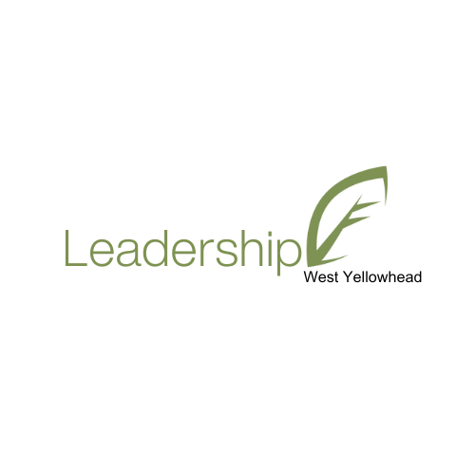

2024 Call for Mentors for Leadership West Yellowhead 2.0
Community Futures West Yellowhead offers the Leadership West Yellowhead program - a community leadership program designed to develop the leadership skills and community awareness of the West Yellowhead region’s next generation of leaders. Currently we are looking for volunteers from our communities in the West Yellowhead to act as mentors for Leadership West Yellowhead participants.
Leadership West Yellowhead’s Mentor Program is a complement to the Retreats and Learning Days and extends the program experience.
Through the Mentor Program, each participant is matched with a more experienced person in their specified area of interest, either career or community related. By design, this self-directed component of the Leadership West Yellowhead program will be different for everyone.
Each mentor relationship will develop in unique ways, based on the ideas and experiences of the individuals involved. The relationship provides an opportunity for learners to further expand their leadership network, and to learn new ideas around leadership, through the connection to a more senior leader in their area of interest.
Mentors can inspire thought, stimulate reflection, tap discovery, and generate new aptitudes in a learner. A mentor is any individual who provides a less experienced person with support, counsel, friendship, reinforcement, and constructive example. Mentors are good listeners, people who care, people who want to help others bring out the strengths that are already there.

Why mentor?
As a mentor, you can help emerging leaders find their way in the world they live in. Being a mentor provides an opportunity to give back through a form of community service.
Mentoring provides significant benefits to the mentor as well. Experienced mentors report that they feel that they get more out of the relationship than they give. While the benefits of mentoring are as diverse as the people who mentor, here are some of the themes heard from mentors: as a mentor you will be making a difference in someone’s life, learning about yourself, giving back, and (we hope!) having fun.
If you are interested in joining Leadership West Yellowhead as a mentor for 2024, please contact General Manager, Nancy Robbins at nrobbins@albertacf.com. All correspondence and inquiries related to the mentor program are confidential and will not be shared with the program participants until the mentor is ready to commit to the program. Interest in the mentor program will be accepted and acknowledged until November 30, 2023.

