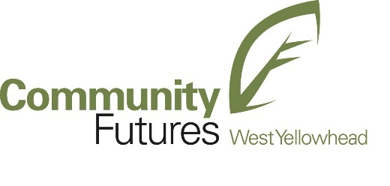
DIGITAL SERVICE SQUAD – TEAM MEMBER
Part-time Term Position to March 31, 2023

Community Futures West Yellowhead is currently seeking outgoing, enthusiastic, qualified individuals for this position.

This is a unique opportunity to support the growth of one of the West Yellowhead’s most innovative economic development programs. The Business Link Digital Economy Program, in collaboration with Digital Main Street, is the first of its kind in Alberta and is funded by the Government of Alberta.

As a member of the Digital Service Squad, you will be a key contributor to the success of the platform and the growth of the program as a whole. Initially, the Digital Service Squad will work remotely with small businesses in the West Yellowhead communities of Jasper, Hinton, Edson, Grande Cache, and Yellowhead County. In the future, the Digital Service Squad will be required to travel independently across the West Yellowhead region.

The focus of this position is to work one-on-one with small businesses and provide the following services:

On-boarding Assistance
  - Conduct pre-business digital assessment to best understand the neighborhood and businesses.
  - Work with the Coordinator to set digital appointments to onboard small businesses to the platform.
  - Walk through the on-boarding survey with the business owner and use appreciative inquiry methods to best understand their business goals and how digital tools/ technology can assist them in meeting those goals.
  - Assist the business in staying in touch with Business Link and Digital Main Street by subscribing to their e-newsletter and social channels.

Advisory Services
  - Once the business has been on-boarded, the Team Member will walk through the Digital Assessment and Recommendations with the business owner.
  - Assist the business owner in identifying their priorities and the first digital tools/technology they want to activate.
  - Review vendor recommendations made through the platform.
  - Lead the business owner to relevant deals/discounts on the platform.

Activation/Implementation Services
  - Activate and implement free, easy-to-use digital tools and technologies that businesses would like to use (i.e. activating social media accounts, creating an online business profile, etc.).
  - Provide some resources (articles, links, how-to guides) available through secondary sources that can help the business owner learn more about a particular tool that has been activated, or subject matter of interest.

Reporting and Feedback
  - Complete field notes and report on a weekly basis to the Program Coordinator and Program Manager.
  - Attend Team Meetings as set out by the Program Manager.
  - Halfway through the employment term, an interim performance evaluation will occur to ensure fit.

The Team Member may be required to attend webinars, workshops and events related to Business Link and Digital Main Street. The purpose of which is to communicate the benefits of the program to business owners and to on-board them to the platform. There may be other duties, as required, that will be discussed with the Team Member should they arise.

Qualified applicants will:
  - Possess strong communications skills (written and verbal).
  - Possess strong interpersonal and relationship building/relationship management skills.
  - Possess excellent organizational and time management skills.
  - Have experience in a sales role and/or marketing environment.
  - Eventually be able to travel and work independently.
  - Be familiar with digital technologies for small business (e.g. web, social media, e-commerce, etc.).
  - Be able to use basic software and collaboration tools such as Microsoft Office Suite (Word, Excel, Outlook, Power Point) and Slack.
  - Previous experience with online and offline marketing is considered a strong asset.
  - Previous experience working with small businesses is considered an asset.

The successful applicant will be expected to work remotely, in the office in Hinton, and be able to travel independently around the region safely.

Please note that the Community Futures West Yellowhead office in Hinton practices the Restricted Exemption Program and has COVID-19 safety measures in place as part of our efforts to help reduce the spread.

You can submit your resume to Nancy Robbins at nrobbins@albertacf.com. Only those individuals selected for an interview will be contacted. Community Futures West Yellowhead thanks all applicants for their submissions.

This job opportunity will remain open until a suitable candidate is found.

